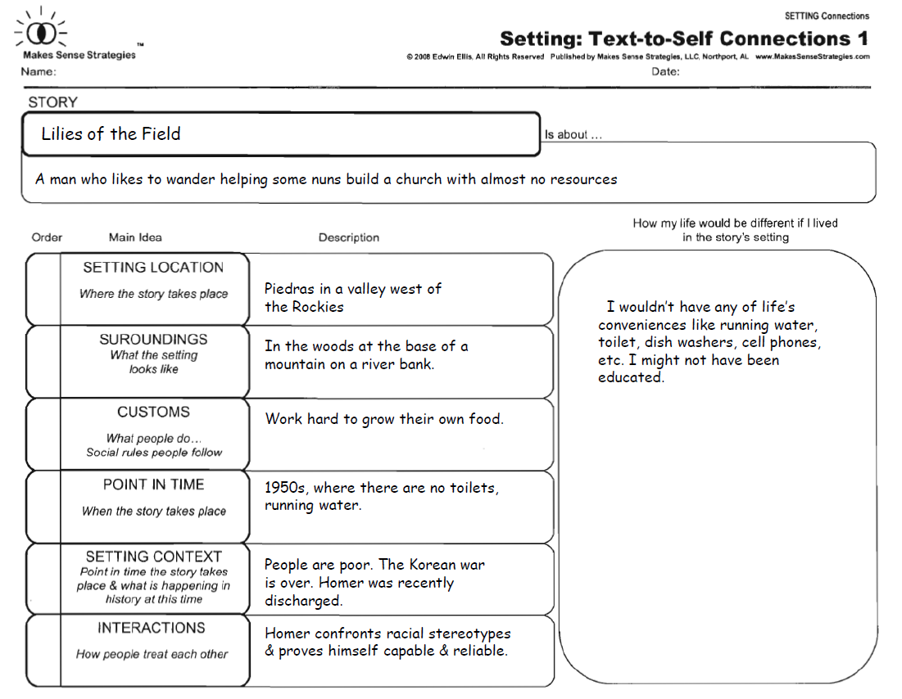

SURROUNDINGS

Desert flat land with few trees.

helps some nuns build a church with almost no resources.