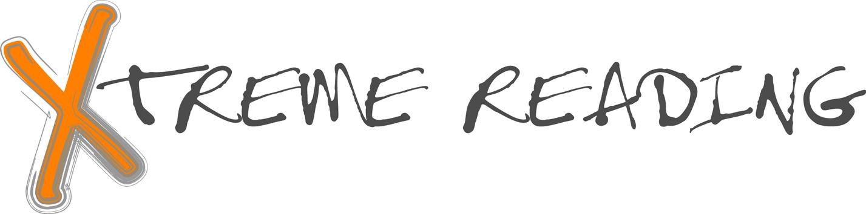
Course Syllabus

Welcome to Xtreme Reading!

By the end of this class, you will be able to:
- Read long multi-syllable words
- Understand what you read (in grade-level materials)
- Use strategies while you read such as:
Word Mapping Strategy
Word Identification
Self-Questioning
Visual Imagery
Paraphrasing
Inferencing
- Learn and be able to use new vocabulary words
- Read aloud smoothly and with expression
- Take reading tests with more confidence and perform better on those tests
- Be a productive member of a Learning Community
- Set and achieve long-term goals

To accomplish the above skills and strategies will require cooperation and the development of a Learning Community.

Think of this class like a challenge course in the forest. You will have to work hard independently, but you will also have to work effectively with other students and me. Together we will create a community of people where taking risks is rewarded with success.

Guidelines for Success (Winners make their own luck. They achieve.)

It takes:
Preparation
Responsibility
Integrity
Dedication
Effort
to be successful!

Classroom Rules (Winners know there are rules and follow the rules.)

1. Come to class every day that you are not seriously ill.
2. Arrive on time with work materials.
3. Raise your hand to speak or ask a question.
4. Follow directions the first time given.
5. Stay on task during all work times.

Learning Activities (Winners participate and strive to ACHIEVE.)

All of the activities below will involve practicing new skills. Think of these activities as the type of practice an athlete, dancer, or musician does to improve skills. Your grades will be based on these activities.

Whole Class Lesson & Discussion
Small Group Work
Paired Practice
Independent Work
Teacher Conferencing

Grades (Winners keep their eye on the score.)

A detailed description of the grading policy is on a separate page.

Classroom Procedures for Learning

Entering the Classroom:

- Be in your seat when the bell rings.
- First four people in the room hand out student binders/folders.
- Begin work on the Start-up Activity on the board when the bell rings.
- Continue to quietly work on this activity until I signal for your attention.

Tardy to Class:

If you are in your seat before the bell rings, you are on time. If you enter after the bell, you are tardy and will lose one behavior point. In addition, all tardies are reported to the attendance office according to school policy.

Materials:

The only material you will need to bring to class is a pencil. If you do not have a pencil, I keep golf pencils and stubs available for your use. Please return the borrowed pencil when finished and donate pencils that you no longer intend to use.

All other materials will be provided for you. Everything except library books will be kept in the classroom. Library books will be checked out for two weeks at a time.

How to find out what the daily assignments are:

I will write the daily assignments on the board. In your binder/folder, you will also find an outline of typical activities for the unit to assist you with your understanding of the work expected.

Turning in assignments:

When I ask for assignments, pass them forward within your row. The first person in each row will put the completed work in the bin that is labeled with this class period.

Returning assignments:

I will return work that I have graded to the bin. Designated students will hand out the graded assignments. When you receive your assignments, look them over and put them in the correct section in your binder or in your folder. Over the course of this year, you will build a portfolio of your work in your binder.

Finding out grade status in class:

A grade print-out will be given to you regularly. This will show your current grade in the class, any missing assignments, and a progress report showing your current reading level.

Student responsibilities after an absence:

Anytime you are absent, you will need to make up the work that you missed. You will have as many days to make up this work as the number of days you were absent. So, if you are absent on Monday and Tuesday, you will have to make up this work and turn it in two days later. PLEASE COME TO THIS CLASS IF YOU ARE NOT SERIOUSLY ILL!!!!! When you miss class, you miss an opportunity to improve your reading!

Communication procedures with parents/guardians:

When you receive a grade print out, you will be asked to share it with your parents/guardian. You will get three bonus points each time you return the print out with your parent/guardian’s signature.

Possible Consequences for Learning Community violations:

Loss of Supporting the Learning Community points
Parental contact
Change in seating assignment
Time owed after class
Detention
Office referral
Student-designed consequences

Ending class:

A couple of minutes before the end of class, all students will return to their assigned seats for final announcements. Students will be excused by rows after the bell rings.

As your teacher, I commit to being a positive part of your success as a learner and a person. You can see me before and after school if you have questions or need additional help. I look forward to working with you. Welcome to the Xtreme Reading class!

