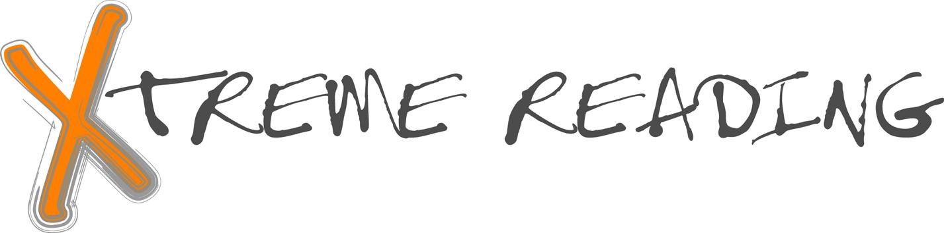

Final Exam Ideas

Since most school districts require final exams for courses, below are some ideas for developing your semester exams.

First Semester Exam Ideas

- Testing of vocabulary words from semester
- Demonstrating word mapping and LINCS
- Supporting a Learning Community (Reflection on purpose and components of a community of learners - ACHIEVE, SCORE, Talking Together)
- DISSECTing unknown words
- Checking the student’s ability to integrate strategies in reading (integration sheet from latest strategy learned to show usage of the various strategies learned to date)
- Providing information on “How am I doing?” (Action Plan Reflection for Possible Selves goals)
- Fluency check
- Book study options: oral, written, group, individual, multi-media, etc.
- Questions drawn from the Verbal Elaboration activity in each strategy manual.
- Questions related to naming the steps of the strategies.

Second Semester Exam Ideas

- Administering GATES
- Testing of vocabulary words from semester
- Checking the student’s ability to integrate strategies in reading (integration sheet from last strategy learned)
- Reflecting on how Xtreme Reading has changed the student
- Fluency check
- Completing a self-evaluation through a Possible Selves Action Plan Reflection
- Book study options: oral, written, group, individual, multi-media, etc.
- Questions drawn from the Verbal Elaboration activity in each strategy manual.
- Questions related to naming the steps of the strategies.

If you don’t measure results, you can’t tell success from failure. If you can’t see success, you can’t learn from it. If you can’t recognize failure, you can’t correct it. (Osborne & Goebler, Reinventing Government)

