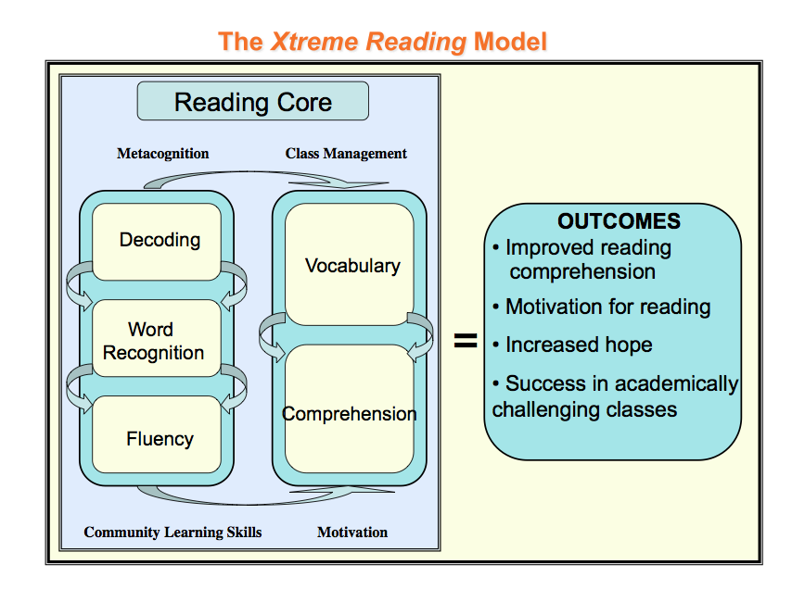

***Xtreme Reading* is a comprehensive program that is designed to provide the consistent, intensive, and explicit instruction that struggling adolescent readers need to become competent and confident readers.**

Teacher materials include 8 teacher notebooks with daily schedules and lesson materials:

* Xpect to Achieve
* Word Mapping
* Word Identification
* Possible Selves
* Self-Questioning
* Paraphrasing
* Inference
* Visual Imagery

\*Teachers also receive the teacher editions of all practice passage books with answer keys and a CD containing “Tools for Efficiency and Effectiveness”.

Student notebooks include consumable worksheets, notes sheets, and cue cards for each of the strategies taught. Books containing expository and narrative leveled passages are included for student practice.