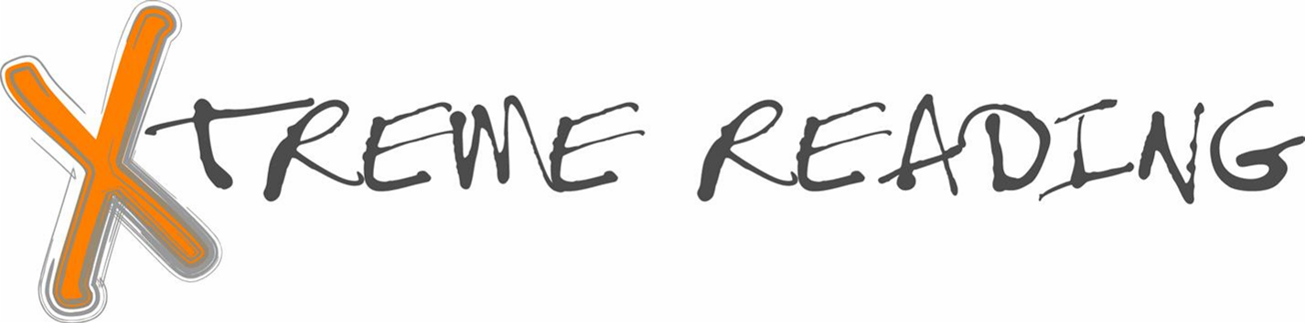 Book Study Activity Rubric #1

CATEGORY | 4 | 3 | 2 | 1 | 0 | Points/Comments
Completeness of info | Your book study activity includes all of the components in the directions.  Your information gives a reader a clear understanding of the book. | Your book study activity includes most of the components in the directions.  A reader may not have a clear understanding of the book. | Your book study activity includes less than half of the components in the directions.  A reader will probably not have a clear understanding of the book. | Your book study activity includes few of the components in the directions.  A reader will have difficulty understanding the contents of the book. | Did not complete the assignment
Spelling, grammar & punctuation | The book study activity is extremely well-written.  Few errors were noted. | The book study activity is very well written.  Few major errors exist. | The book study activity has several major errors throughout.  The book study activity appears not to have been proofread. | Errors are frequent and distracting to the reader.  The book study activity appears not to have been proofread. | Did not complete the assignment
Neatness and Effort | The book study activity has no distracting errors, corrections or erasures and is easily read.  It gives the impression the author spent a lot of time and effort to create it. | The book study activity has few distracting errors, corrections or erasures and is easily read.  It gives the impression the author put a lot of effort to create it. | The book study activity is fairly readable but the neatness and effort quality is lacking in some parts.  It gives the impression the author ran out of time or didn't give his or her best effort. | The lack of neatness makes the book study activity hard to read.  It gives the impression the author spent very little time creating it. | Did not complete the assignment
Adapted from Rubistar (http://rubistar.4teachers.org/index.php) book report rubric by Laney.

Bonus Points:  10 points (Chose challenging book above your reading level)
- 5 points (Chose a book at your reading level)
- 3 points (Perfect score on rubric above)

