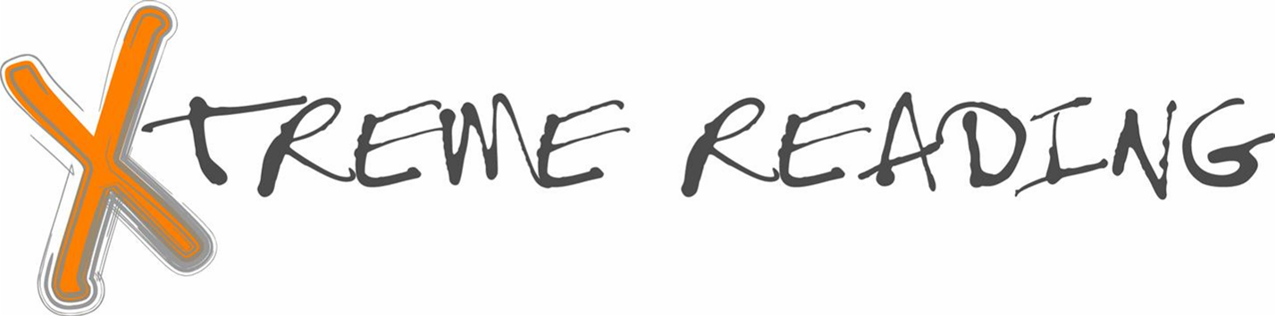Brochure Book Study Activity Rubric

CATEGORY | 4 | 3 | 2 | 1 | Points/Comments
Completeness of info | Your brochure includes the 7 requirements (title, author’s name, description of the setting or place for the story, a description of the main character’s problem or challenge, a rating for the book, a description of what you learned from the book or what it meant to you, and pictures related to the book). Your description gives a reader a clear understanding of the book. | Your brochure includes 5-6 of the requirements. A reader may not have a clear understanding of the book. | Your brochure includes 3-4 of the requirements. A reader will probably not have a clear understanding of the book. | Your brochure includes 1-2 of the requirements. A reader will have difficulty understanding the contents of the book.
Spelling, grammar & punctuation | The brochure is extremely well-written. Few errors were noted. | The brochure is very well written. Few major errors exist. | The brochure has several major errors throughout. The brochure appears not to have been proofread. | Errors are frequent and distracting to the reader. The brochure appears not to have been proofread.
Neatness and Effort | The brochure has no distracting errors, corrections or erasures and is easily read. It gives the impression the author spent a lot of time and effort to create it. | The brochure has few distracting errors, corrections or erasures and is easily read. It gives the impression the author put a lot of effort to create it. | The brochure is fairly readable but the neatness and effort quality is lacking in some parts. It gives the impression the author ran out of time or didn't give his or her best effort. | The lack of neatness makes the brochure hard to read. It gives the impression the author spent very little time creating it.
Following directions | The brochure completely conforms to the brochure assignment directions. | The brochure mostly conforms to the brochure assignment directions. | The brochure assignment directions were not followed in a few instances. | The brochure assignment directions were not followed.

Bonus Points:  10 points (Chose challenging book above your reading level)
- 5 points (Chose a book at your reading level)
- 1 point (Perfect score on rubric above)

Adapted from Rubistar (http://rubistar.4teachers.org/index.php) book report rubric by Laney.

