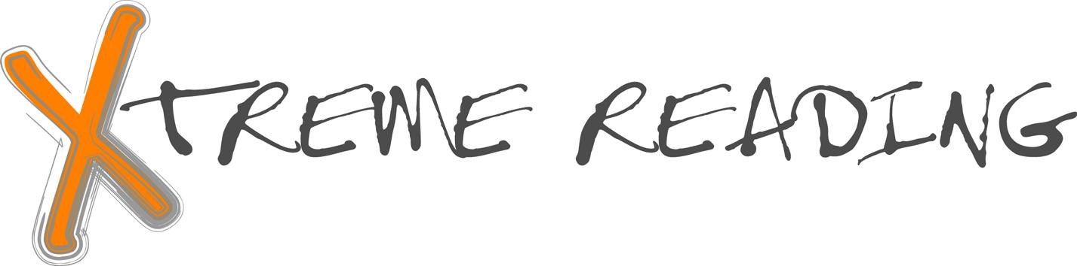
Book Interview

Student Name ___________________________________Date

What is the title of the book?

Who is the author?

How many pages does the book have?
Who is the main character?
What is the age of the main character?
What is the main problem faced by the main character?

What are three important actions of the main character?
1.

2.

3.

What are three important scenes in the book (places the action takes place)?
1.
2.
3.
What are two ideas or themes that this book makes you think about?
1.
2.
3.
On the back write a 50-75 word summary completing each of the following statements:
In the beginning ……. In the middle…. In the end…. I would recommend this book because…

